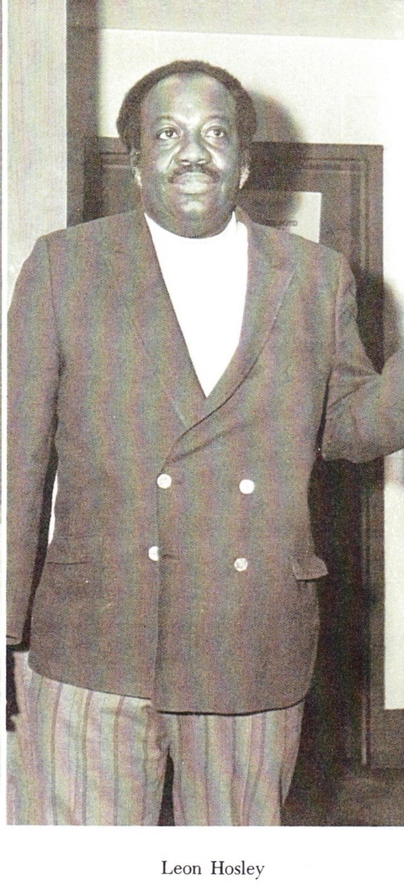1971 Yearbook

Leon Davis Holsey, 83, professor who taught at Coppin State College

**Jacques Kelly**THE BALTIMORE SUN

July 17, 2004

Leon Davis Holsey, a retired social science professor at Coppin State College who infused African culture into the curriculum during the four decades he taught there, died July 10 of cancer at his Northwood home. He was 83.

Born in Baltimore and raised on McCulloh and on Division streets, he attended Frederick Douglass High School. Finding the attitude there elitist, he dropped out of the 10th grade and worked in shipyards. He also sold newspapers, scrubbed floors and marble steps, and cleaned yards. His father, a ship's caulker, insisted that he continue his education at night in an adult program offered by the city schools.

"It was the best thing my father ever made me do," Dr. Holsey said in a 1999 article in The Sun. "Those adults became my mentors. They taught me so much about life I could never have gotten in the academic world."

Dr. Holsey went to sea in the merchant marine, serving on ships throughout World War II. Years before the armed forces were integrated, he said, all races were treated equally on these ships.

"In training, we lived together, ate together, slept together," he said in the 1999 interview. "We knew all about each other. When we got out on those ships, our lives depended on each other."

The merchant marine took him to Egypt while carrying relief supplies to India. He later traveled to Africa 40 times on vacations, for research, leading tour groups, studying spiritual systems and making the trip to bury his wife, Anna Dugger, who died in 1998.

"He was extremely knowledgeable about the people and their culture. He seemed to know people wherever he went," said a cousin, Francena Bean-Waters, of Baltimore. "He took us to the bush country ... not just to the cities. We got to know the indigenous people and saw performances and rituals."

He was given many African names from different countries. He also collected carvings, paintings and photographs.

After the war, he attended [Lincoln University](https://www.baltimoresun.com/topic/education/colleges-universities/lincoln-university-OREDU000742-topic.html) and earned an economics and political science degree from Morgan State University. He received a master's degree from New York University and a doctorate from California Coast University. He also studied at American University, among other institutions, and was a member of the Beta Sigma Tau Fraternity.

Dr. John Hudgins, chairman of Coppin State's social sciences department, said that Dr. Holsey's retelling of Baltimore history -- including stories about W.E.B. Du Bois and Thurgood Marshall -- was even more fascinating than his talks about Africa.

In the 1960s, Dr. Holsey took a leave from teaching in city schools to work for a War on Poverty program that took him across the United States. He saw poverty in Appalachia, on Native American reservations and in inner cities. "It was wonderful working with all those ethnic groups," he said. "I never really understood the whole melting pot."

He said he came back from that experience more convinced of the need for African-Americans to understand their heritage. With the social revolution of the late 1960s sweeping college campuses, he got an opportunity to turn that view into college courses, first at Towson State College in 1969, then at Coppin. There he found students eager for Afrocentric courses, but many in the faculty and administration were resistant, The Sun's 1999 article said.

"Middle-class blacks didn't want anything to do with Africa back then," he said.

Holsey had taught part time at Coppin for eight years before joining the faculty in 1970. He spent the rest of his teaching career at the institution, where one of his principal courses was "People and Politics of Africa." He retired in 1999.

"He was one of the more popular professors," Dr. Hudgins said. "He was a warm and talkative man. Even when he didn't agree with students, he was careful to treat them fairly."

Services will be held at 10:15 a.m. Tuesday at the Vaughn C. Greene Funeral Home, 4905 York Road.

Besides his cousin, survivors also include a daughter, Arlene Holsey, a stepdaughter, Deborah Drake, and a niece, Burrell Holsey, all of Baltimore.

Copyright © 2021, [The Baltimore Sun](http://www.baltimoresun.com/#nt=copyright), a Baltimore Sun Media Group publication | [Place an Ad](http://placeanad.baltimoresun.com/)

* [Lincoln University](https://www.baltimoresun.com/topic/education/colleges-universities/lincoln-university-OREDU000742-topic.html#nt=taxonomy-article)